SWIFT-Access Request

Link For Access Management:-

<https://uswasgdq.deloitte.com/sec#Shell-home>

*Must connect to Deloitte VPN before go through the link .

Steps To Raise The Access Request:-

Common steps:-

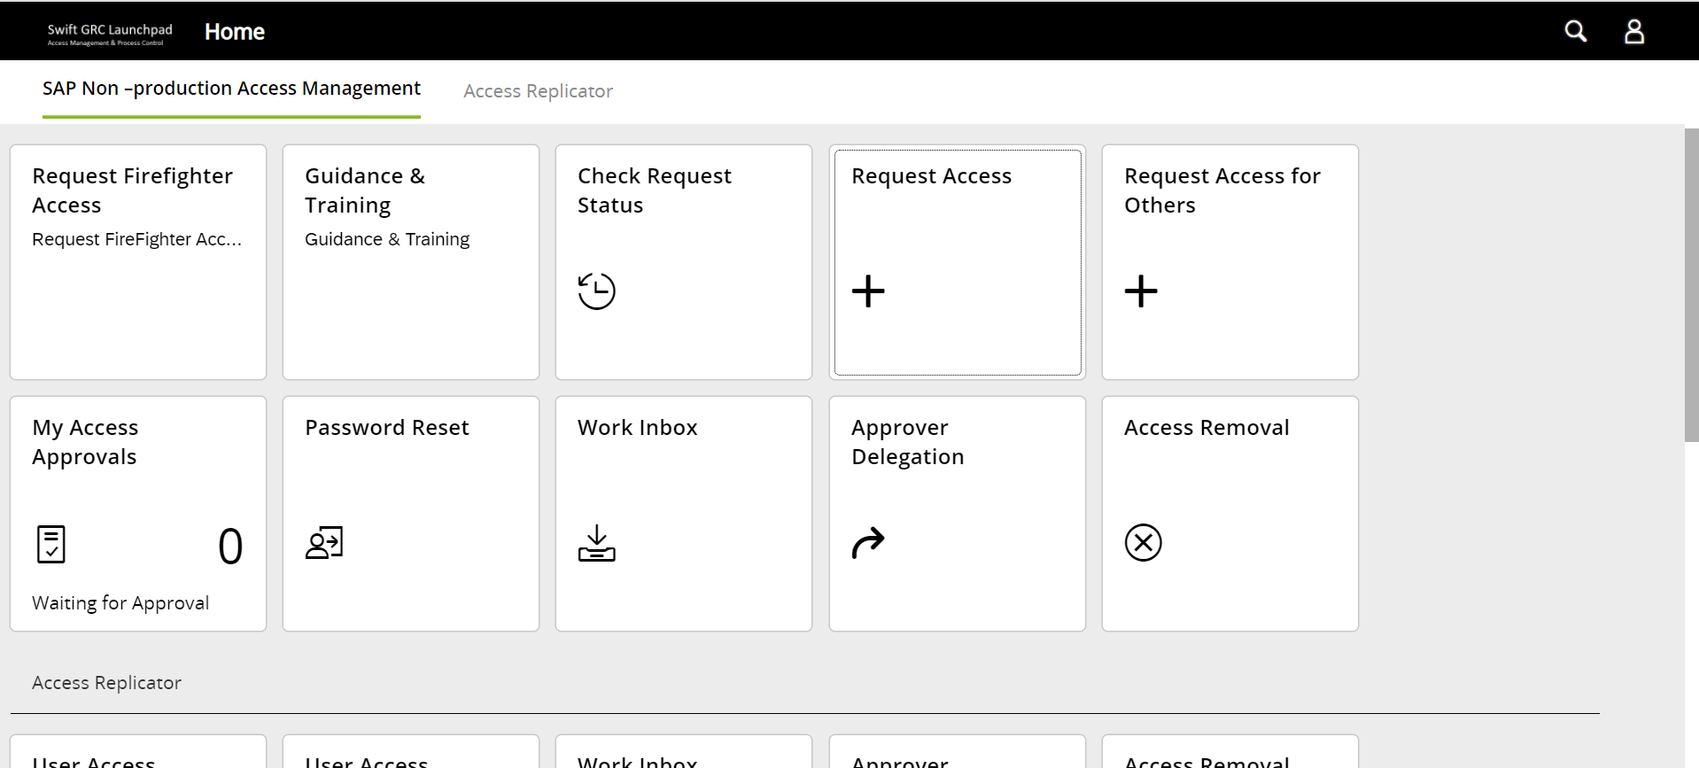

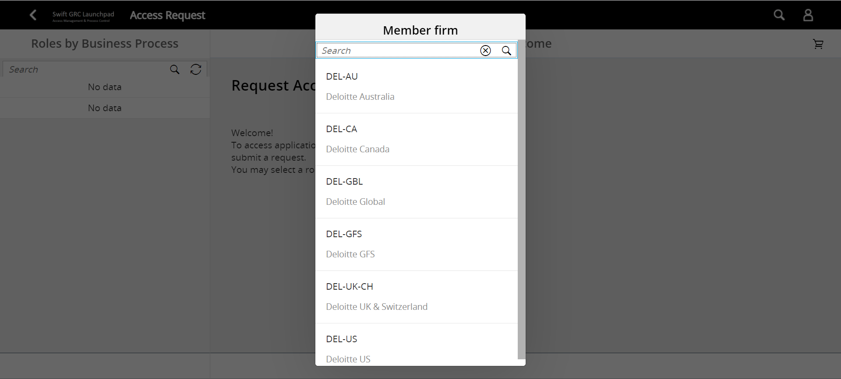

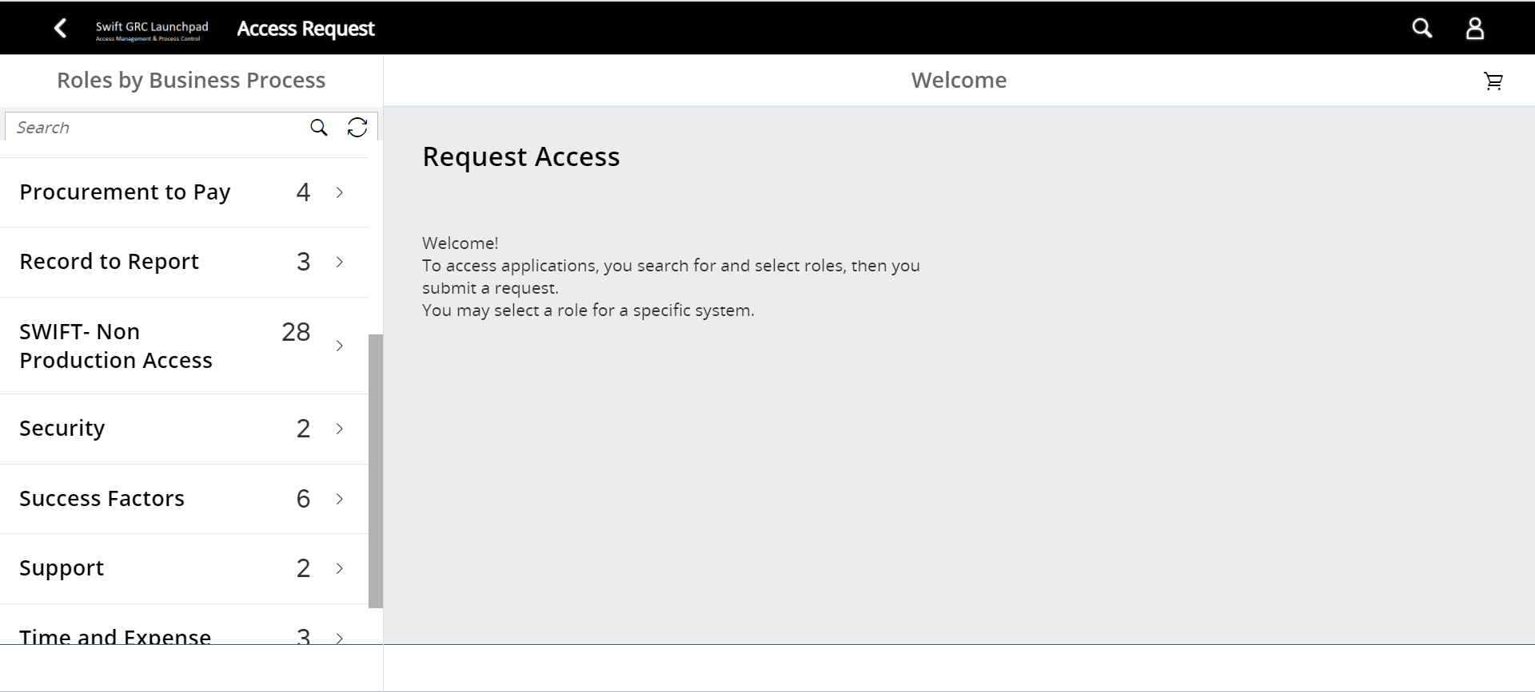

Request Access For SWIFT_ABAP_DEVELOPER_SDD30:-

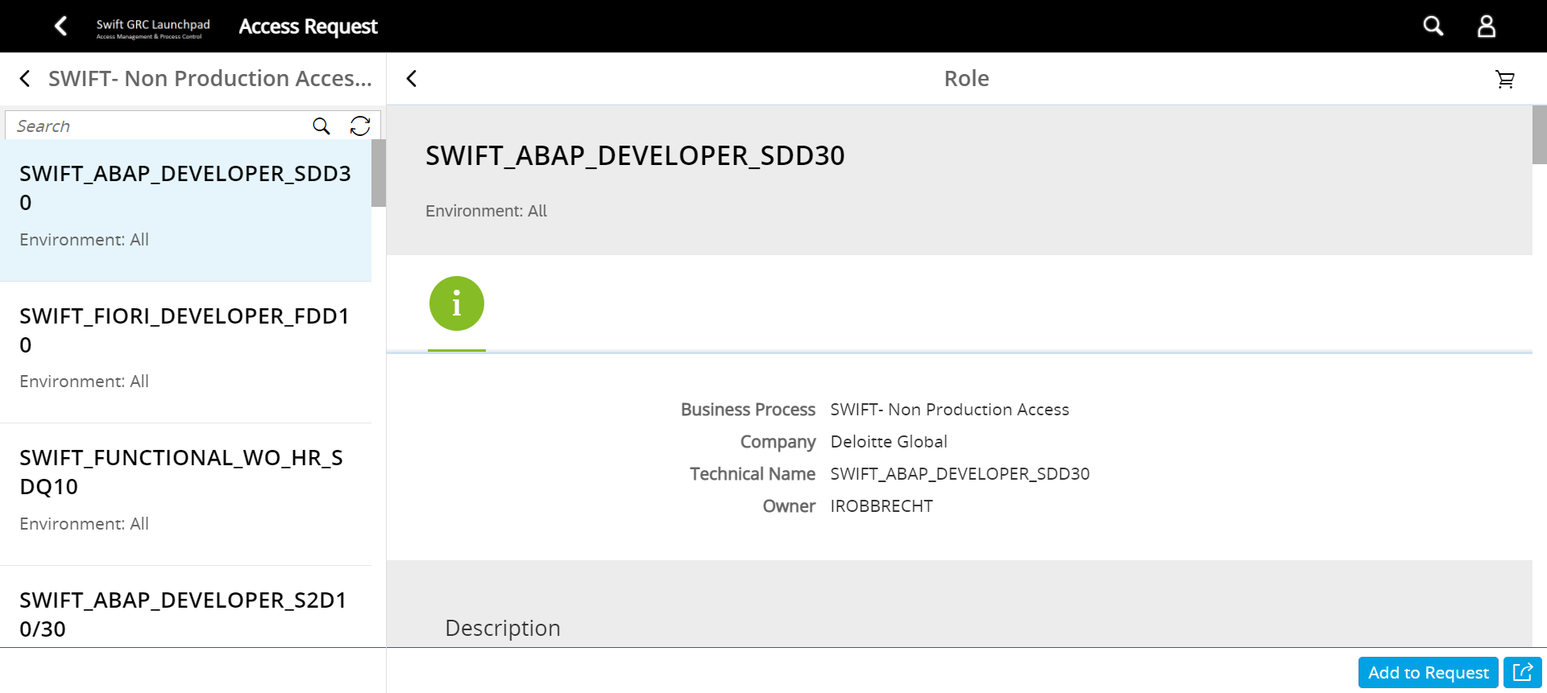

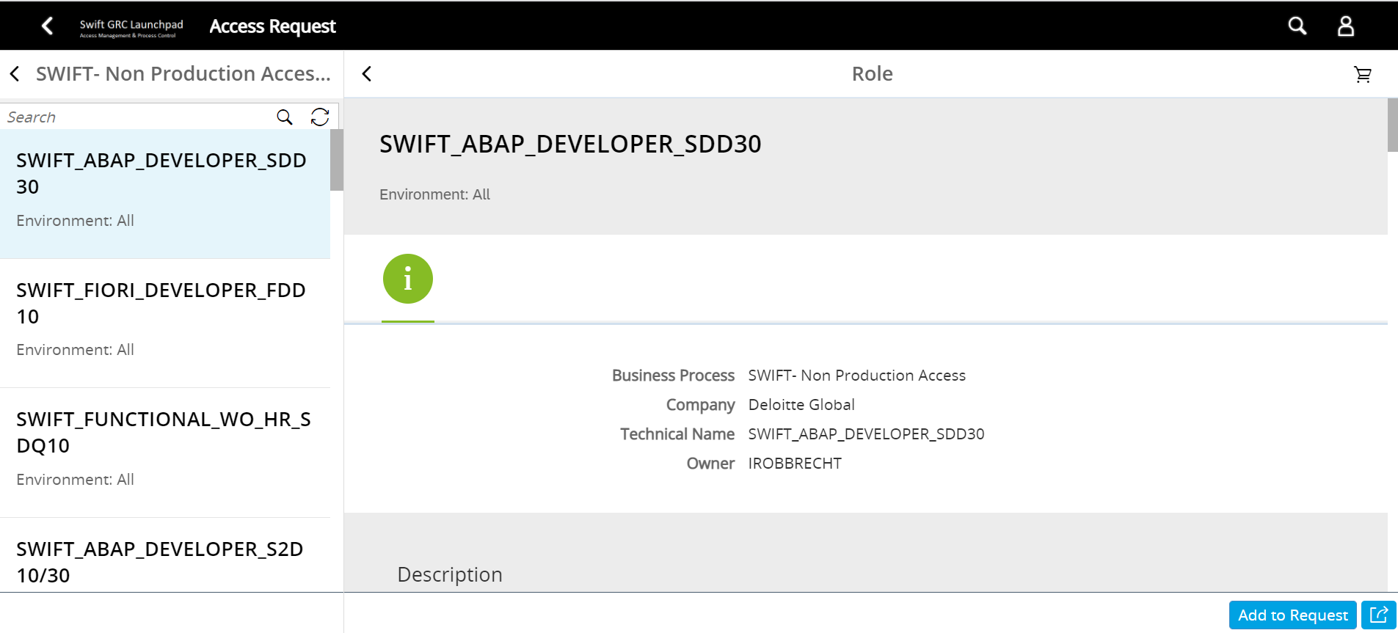



Access Request For SWIFT_DISPLAY_ALL_WITH_HR_SDD30:-

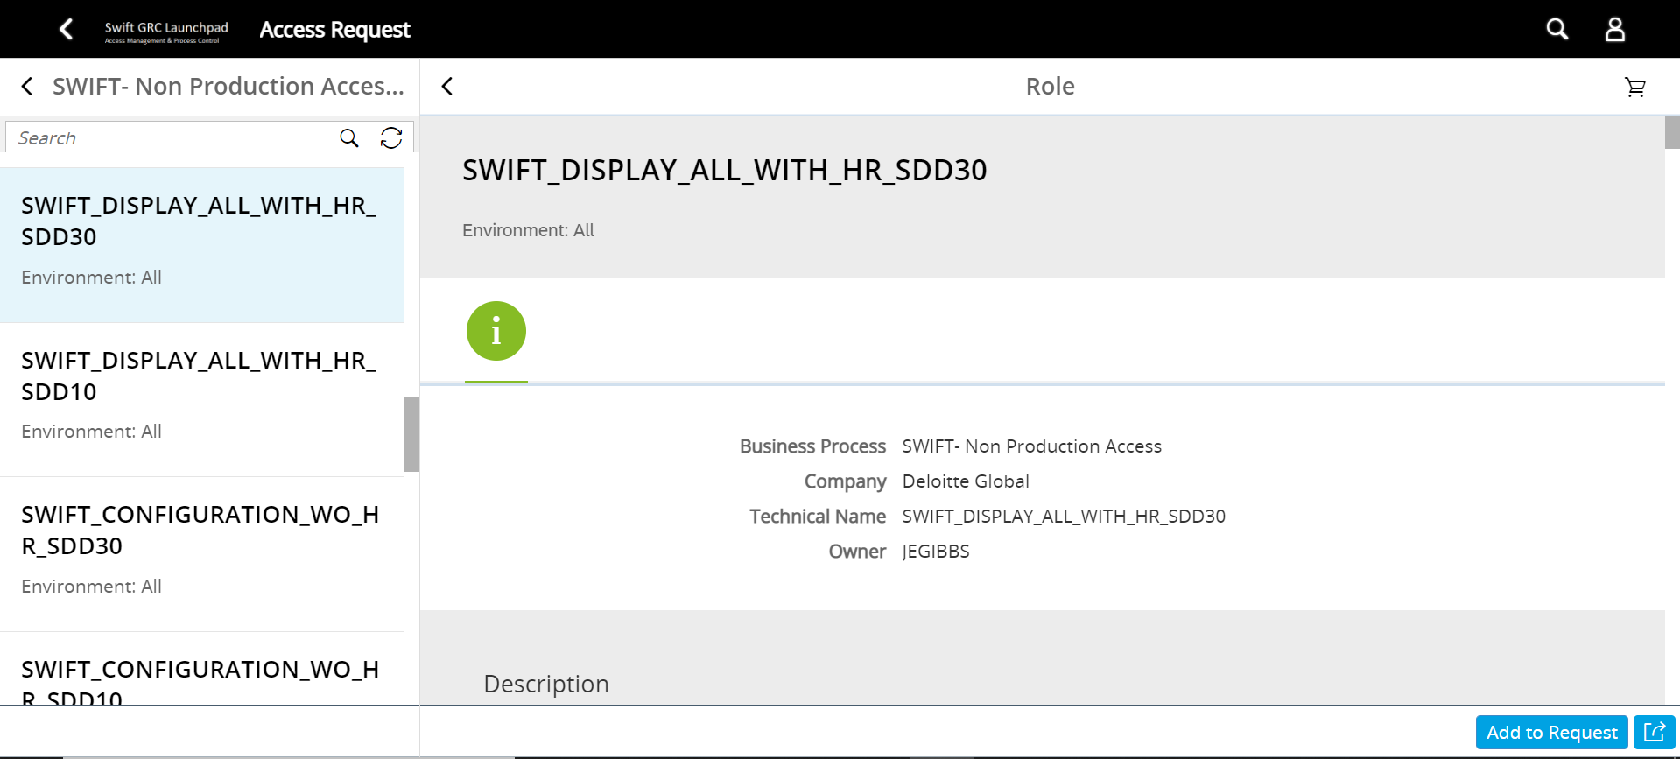



Access Request For SWIFT_DISPLAY_ALL_WITH_HR_SDD10:-

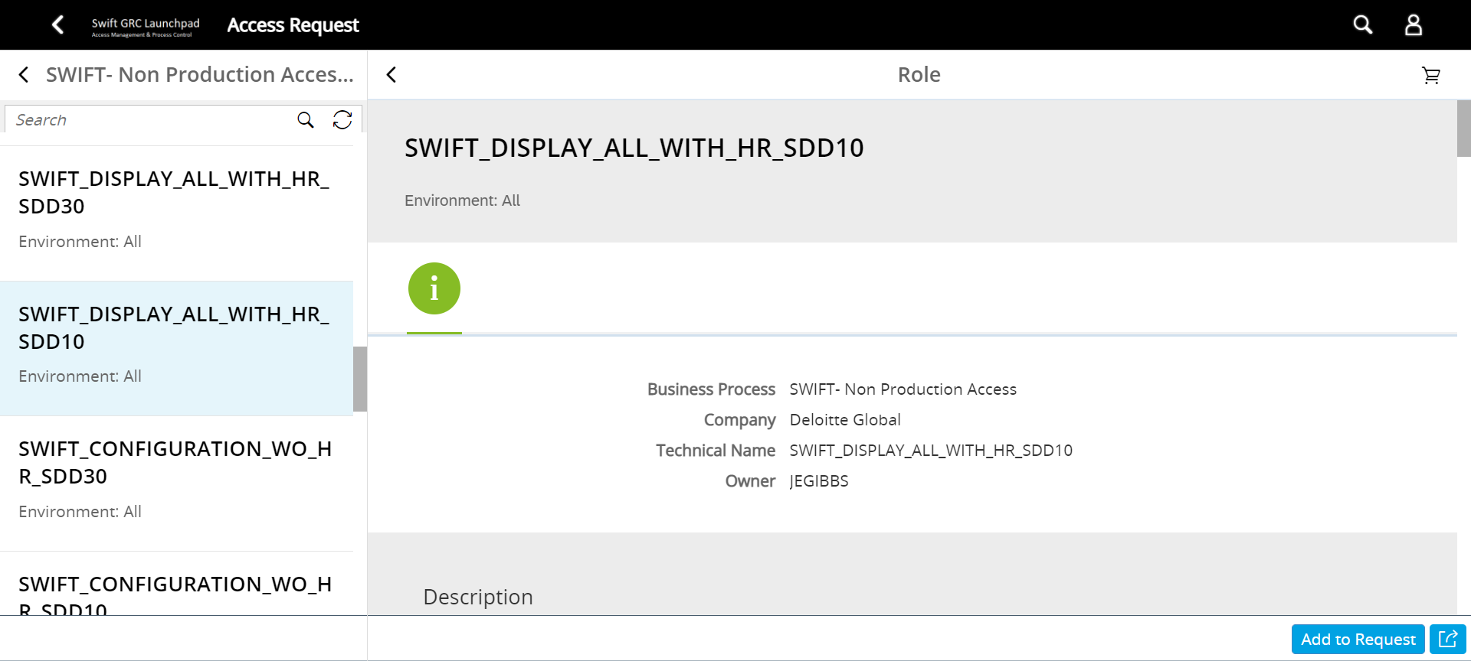

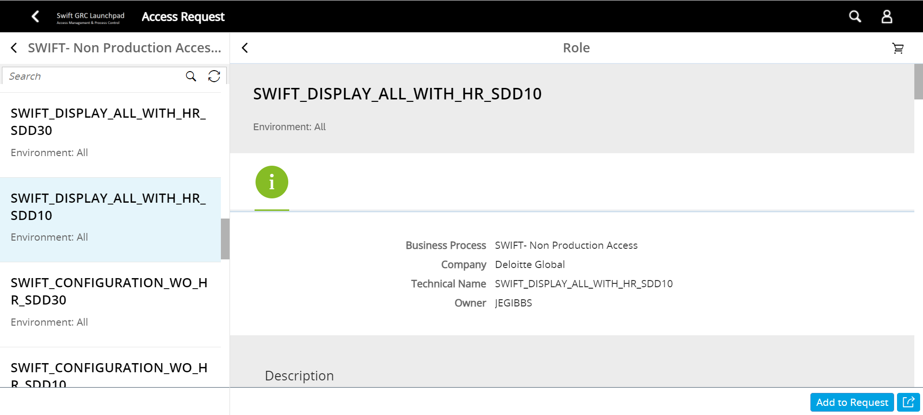

Access Request For SWIFT_ABAP_DEVELOPER_SDD10:-

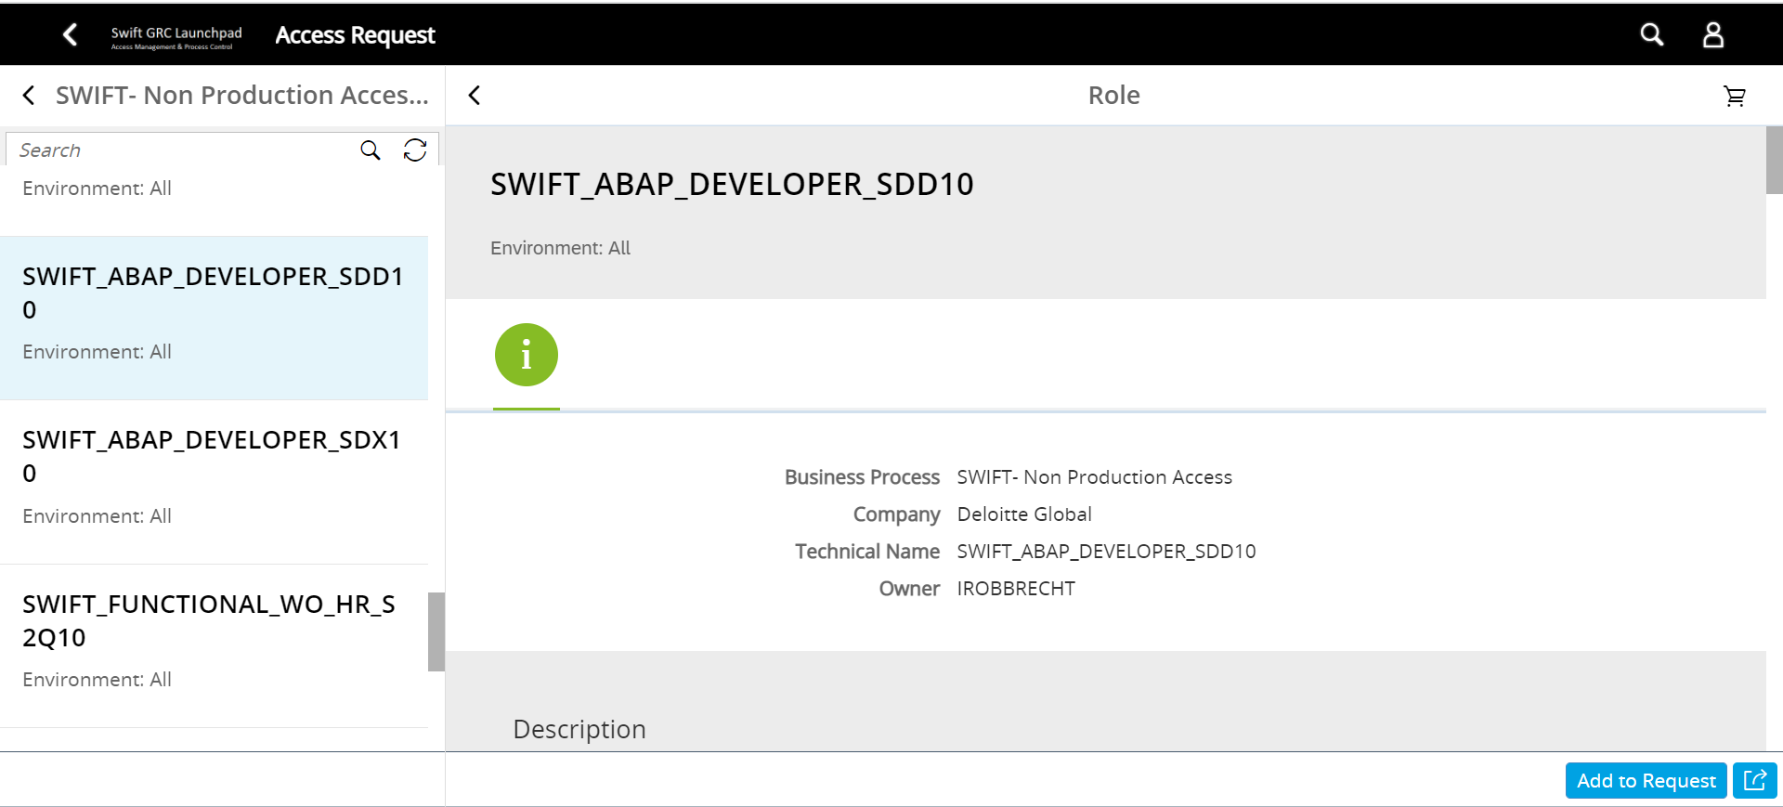



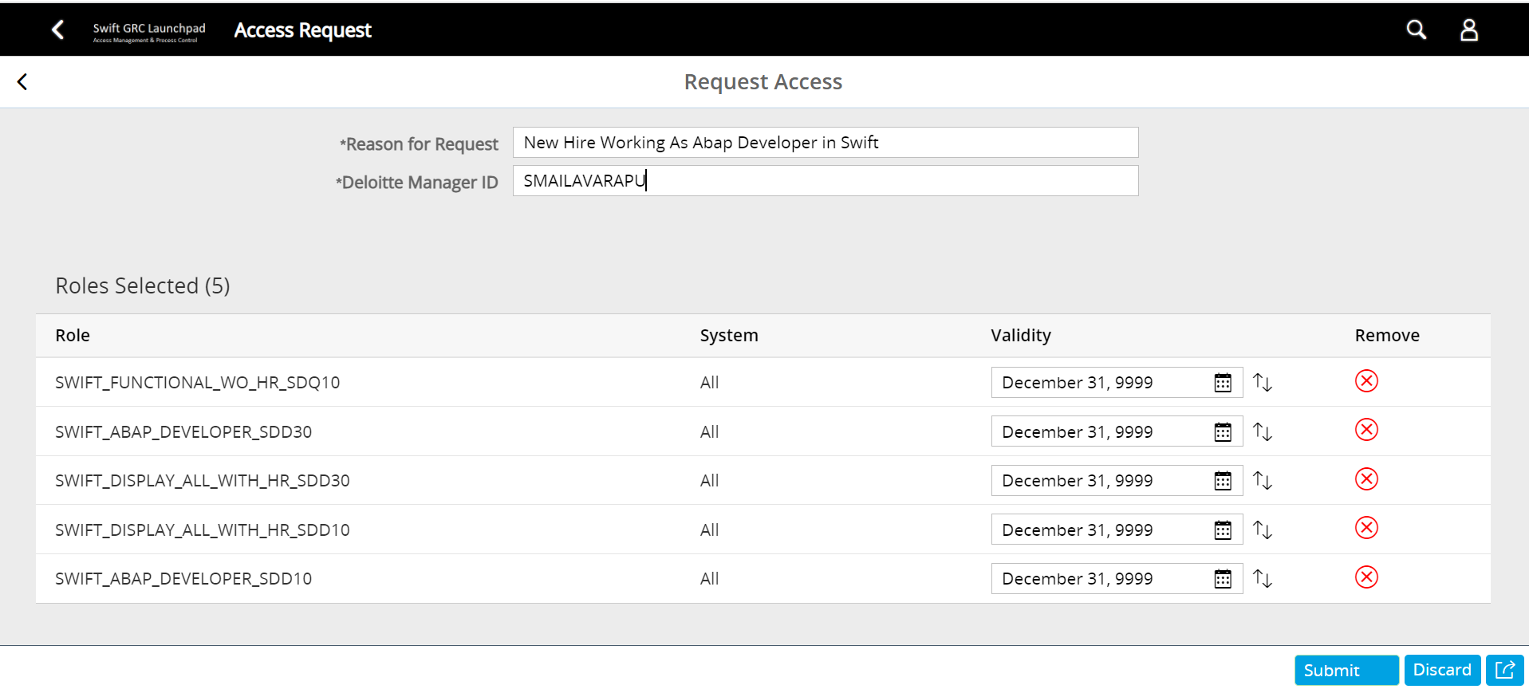

Steps To Raise Access Request For CHARM:-

Link :- <https://uswasgdp.deloitte.com/sec#Shell-home>

